Antolaketa Unitateak
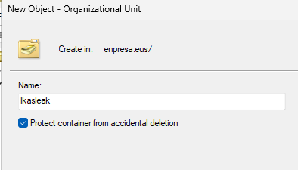
# Network adapter
$adapterName = "Ethernet"
# IP and DNS
$serverAddress = "192.168.1.100"
$clientAddress = "192.168.1.50"
$prefixLenght = 24
$gateway = "192.168.1.2"
$dnsAddresses = @("172.17.10.9", "8.8.8.8")
# Hostname
$hostname = "server"
# Active Directory
$domainName = "enpresa.eus"
$domainNetName = "ENPRESA"
$adminPassword = "Admin123*"
# Organizative Units
$parts = $domainName.Split(".")
$domain1 = $parts[0]
$domain2 = $parts[1]
$OUName = @("Langileak", "Ikasleak", "Informatika", "Mekanika", "Medikuntza")
$OUPassword = @("Langileak123*", "Ikasleak123*")
$OUId = 1 # 1 = Ikasleak
# OU bat sortu
New-ADOrganizationalUnit -Name $($OUName[$OUId]) -Path "OU=$($OUName[$OUId]),DC=$domain1,DC=$domain2"
# Informatika, Mekanika, Medikuntza
New-ADOrganizationalUnit -Name $($OUName[2]) -Path "OU=$($OUName[$OUId]),DC=$domain1,DC=$domain2"
New-ADOrganizationalUnit -Name $($OUName[3]) -Path "OU=$($OUName[$OUId]),DC=$domain1,DC=$domain2"
New-ADOrganizationalUnit -Name $($OUName[4]) -Path "OU=$($OUName[$OUId]),DC=$domain1,DC=$domain2"
# Medikuntza OU ezabatu
Set-ADOrganizationalUnit -Identity "OU=$($OUName[4]),OU=$($OUName[$OUId]),DC=$domain1,DC=$domain2" -ProtectedFromAccidentalDeletion $false
Remove-ADOrganizationalUnit -Identity "OU=$($OUName[4]),OU=$($OUName[$OUId]),DC=$domain1,DC=$domain2"
# OU guztiak bistaratu
Get-ADOrganizationalUnit -Filter *

Domeinu-erabiltzaileak
$OUId = 2 # 3 = Informatika
$DUName = "Xanet Zaldua"
$DUParts = $DUName.Split(" ")
$DUGivenName = $DUParts[0]
$DUSurname = $DUParts[1]
$DUGivenNameLow = $DUGivenName.ToLower()
$DUSurnameLow = $DUSurname.ToLower()
$DUAccountName = "$($DUGivenNameLow[0])$DUSurnameLow"
New-ADUser `
-Name $DUName `
-DisplayName $DUName `
-GivenName $DUGivenName `
-Surname $DUSurname `
-SamAccountName $DUAccountName `
-UserPrincipalName "$DUAccountName@$domainName" `
-Path "OU=$($OUName[$OUId]),OU=$($OUName[1]),DC=$domain1,DC=$domain2" `
-AccountPassword (ConvertTo-SecureString $OUPassword[1] -AsPlainText -Force) `
-Enabled $true
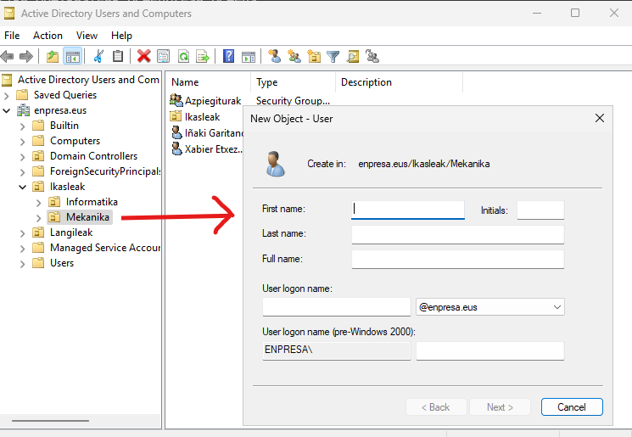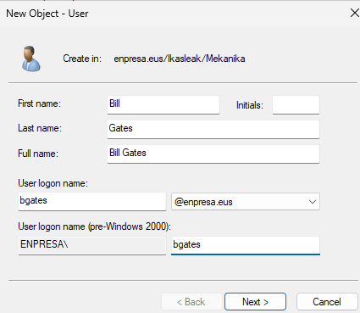

Erakutxi erabiltzaileak
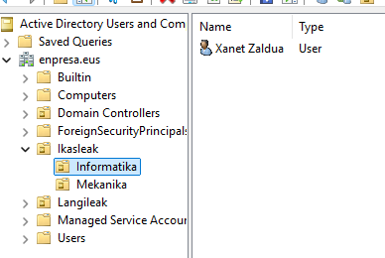
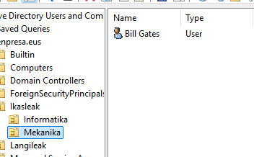
Domeinu-taldeak
$groupName = "Bigarren"
$OUId = 2 # 3 = Informatika
New-ADGroup `
-Name $groupName `
-SamAccountName $groupName `
-DisplayName $groupName `
-GroupScope Global `
-GroupCategory Security `
-Path "OU=$($OUName[$OUId]),OU=$($OUName[1]),DC=$domain1,DC=$domain2"
Get-ADGroup -Identity $groupName
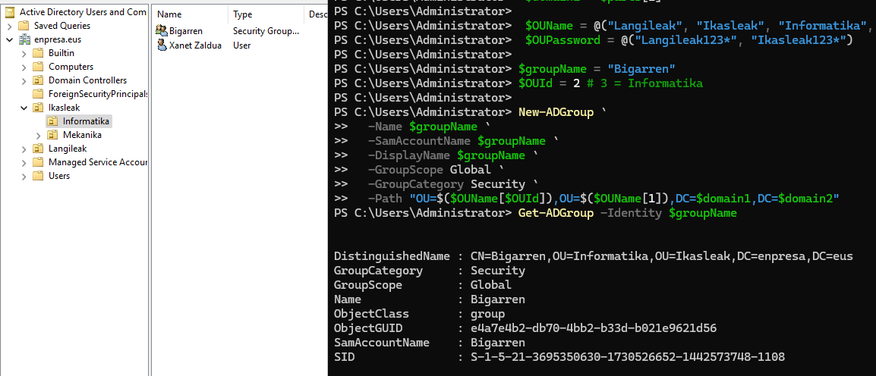
$userAccount = "xzaldua"
$groupName = "Bigarren"
Add-ADGroupMember -Identity $groupName -Members $userAccount
Get-ADGroupMember -Identity $groupName | Select-Object Name, SamAccountName
